*EXPERIMENT 0:-* Hands on Breadboard and Multimeter

*CIRCUIT DIAGRAM:*

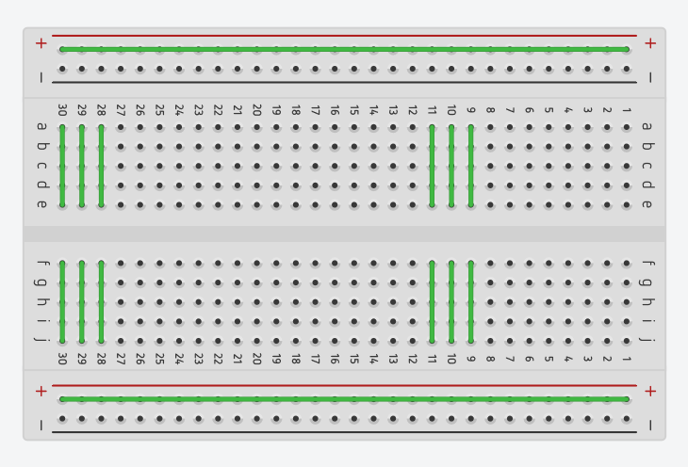

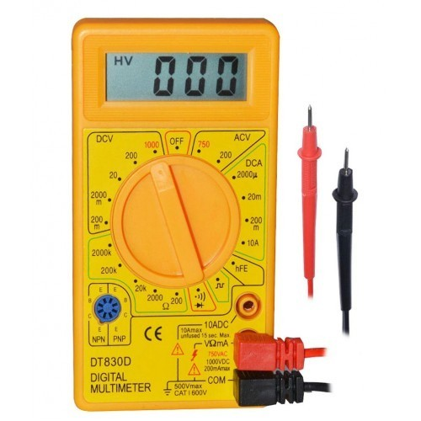

*THEORY:*

A breadboard is a construction base for [prototyping](https://en.wikipedia.org/wiki/Prototype) of [electronics](https://en.wikipedia.org/wiki/Electronic_circuit). Originally the word referred to a literal bread board, a polished piece of wood used for slicing bread.[[1]](https://en.wikipedia.org/wiki/Breadboard#cite_note-1) In the 1970s the solderless breadboard (a.k.a. plugboard, a terminal array board) became available and nowadays the term "breadboard" is commonly used to refer to these.

Because the solderless breadboard does not require [soldering](https://en.wikipedia.org/wiki/Soldering), it is reusable. This makes it easy to use for creating temporary prototypes and experimenting with circuit design. For this reason, solderless breadboards are also popular with students and in technological education. Older breadboard types did not have this property.

A breadboard is a rectangular plastic board with a bunch of tiny ports in it. These ports are used for connection of the electronic devices.

* In Breadboard, the rows on top and bottom are connected in series whereas in middle the connections is column wise.
* No soldering is required when you are using breadboard.
* Connections in breadboard are not permanent and can be easily removed in case of any mistake.
* Electrical components with leads are held in place by the holes of the breadboard.

A **multimeter** or a **multitester**, also known as a **VOM** (volt-ohm-milliammeter), is an [electronic](https://en.wikipedia.org/wiki/Electronics) [measuring instrument](https://en.wikipedia.org/wiki/Measuring_instrument) that combines several measurement functions in one unit. A typical multimeter can measure [voltage](https://en.wikipedia.org/wiki/Voltage), [current](https://en.wikipedia.org/wiki/Electric_current), and [resistance](https://en.wikipedia.org/wiki/Electrical_resistance). **Analog multimeters** use a [microammeter](https://en.wikipedia.org/wiki/Microammeter" \o "Microammeter) with a moving pointer to display readings. **Digital multimeters** (DMM, DVOM) have a numeric display, and may also show a graphical bar representing the measured value. Digital multimeters are now far more common due to their lower cost and greater precision, but analog multimeters are still preferable in some cases, for example when monitoring a rapidly varying value.

A multimeter is a device used to measure voltage, resistance and current in electronics & electrical equipment. It is also used to test continuity between to 2 points to verify if there are any breaks in circuit or line.

If circuit is continuous, buzzing in the multimeter can be heard.

**Learning & Observations**:

* Here we learned how to make connections on breadboard .
* We also learned how to make series and parallel connection of different electrical components.
* We learned how to measure DC voltage ,DC current, resistance ,and continuity using Multimeter.

*PROBLEMS AND TROUBLESHOOTING:*

* Many a times the connections didn’t work as desired due to the misunderstanding of the connections of rows and columns.
* The pins sometimes didn’t insert properly due to which the circuit didn’t work .

*PRECAUTIONS:*

* Shorten the leads — particularly of connector or jumper wires — so that they are not going to cross into a component's leads.
* Always connect the power supply to the breadboard last.
* Use the appropriate range to measure the parameters using multimeter.
* Avoid crowding breadboard space because it will make reconnections a simpler prospect.

*LEARNING OUTCOMES*

Here we learned how to use multimeter and make connections on breadboard